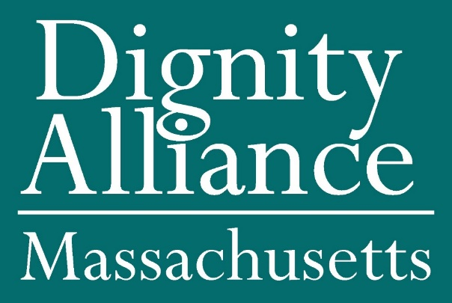
info@DignityAlliance.org

October 30, 2020

Representative Claire Cronin
House Chair, Judiciary Committee
State House - 24 Beacon Street
Room 136
Boston, MA 02133

Senator Jamie Eldridge, Chair
Senate Chair, Judiciary Committee
State House - 24 Beacon Street
Room 511-C
Boston, MA 02133

RE: H4978/S2818 An Act To Address Estate Recovery Issues Due To COVID-19

Dear Chairs of the Judiciary Committee:

The Dignity Alliance submits this testimony in support of H4978/S2818 An Act To Address Estate Recovery Issues Due To COVID-19 filed by Representative Christine Barber and Senator Joanne Comerford. The Alliance includes __ members who represent organizations and individuals working on behalf of older adults and people with disabilities. The Alliance supports this legislation because it will provide critical relief to individuals and families who are suffering during this health emergency.

Dignity Alliance, as the state’s largest and most diverse coalition of organizations and individuals with experience in this area of long-term care, believes the COVID crisis must spur a restructuring of long-term services, support, and care in the Commonwealth. We must embrace the principle of respecting the human dignity of care receivers and givers alike, and ensure that people have access to the best public health practices. The budget issues that we support, some with reservations or additional recommendations, represent important steps toward achieving an “age-friendly Commonwealth.”

Under the MassHealth statute, Massachusetts is among the states that seek estate recovery for the costs of medical care not only for nursing home care, but for the costs of all medical services for individuals age 55 and older even if they have never received nursing home care. Since March, MassHealth members have been at increased risk for death as a result of COVID-19, especially residents of long-term care facilities. One consequence of this enormous tragedy is the hardship to those individual’s spouses and families who, in addition to dealing with the loss of a loved one, must negotiate the probate process. The difficulty is compounded by the unfortunate economy, the lack of in-person communications, the inability of individuals to safely empty a house for sale or safely relocate, all of which make it extremely difficult to meet the deadlines in the estate recovery statute. Families are being unfairly burdened because they are unable to resolve the claims due to situations beyond their control.

This legislation will establish some needed relief from estate recovery during the state of emergency to relieve the strain on families who are suffering a loss and financial hardship. The bill does this by
extending the 60 days to 180 days for the public representative to respond to MassHealth regarding the claims against the estate. The bill also eliminates, during the state of emergency, the 12% interest on the MassHealth claims that begins to accrue. And lastly, the legislation would not allow MassHealth to take any action to compel the sale of real estate to meet the estate recovery claim during the state of emergency if an individual is currently residing there. With the lifting of these three requirements during the state of emergency, family members will receive some relief from the burdens of estate recovery.

The Dignity Alliance strongly urges the Committee to provide this legislation with a favorable report.

If you have any questions regarding this legislation, please contact Nomita Ganguly at nganguly@verizon.net.

Sincerely,

Paul Lanzikos, for Dignity Alliance

