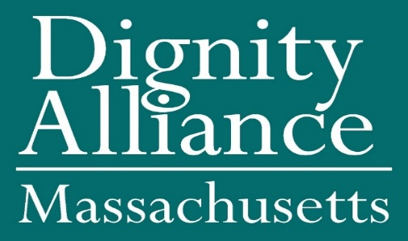

Date
Governor Charles Baker
State House
Room 280
Boston, MA 02133

RE: Covid-19 testing for older adults and persons with disabilities living in independent housing complexes and other congregate living situations

Dear Governor Baker:
Dignity Alliance Massachusetts has been formed in response to the structural and systemic issues in the delivery of long-term services, support, and care that were exposed in the wake of the Covid-19 pandemic. Dignity Alliance is a state-wide coalition of more than thirty-five aging and disability service and advocacy organizations and scores of individuals dedicated to implementing and expanding access to essential care improvements and living alternatives for older adults and people with disabilities. We are dedicated to working with your Administration, the Legislature, and the provider community to ensure that state-of-the-art long-term services and care and a full array of living choices are available within the Commonwealth.
We share your belief, as stated in Executive Order 576, that “older adults should be able to choose to remain in their communities as they age, and this requires access to a broad range of public and private programs, resources, and informal supports to promote healthy, purposeful aging.” In that regard and in this era of COVID-19, we believe that it is essential to provide free access to testing to all older adults and persons with disabilities living in congregate settings regardless of licensing categories, including independent living residences and public housing.
Consequently, we were disappointed to learn from media reports (attached), while state supported Covid-19 testing nursing homes and assisted living residences has increased, independent senior living facilities have generally been left out of this process. It certainly is not consistent with public health practice, especially in environments where independent living units operate with shared common areas with nursing homes and assisted living, to leave those seniors who live independently to fend for themselves. It is our opinion that state supported Covid-19 testing should be widely available to older adults and people with disabilities in congregate residential settings, group homes, senior centers, and other locations where seniors interact.
As you know, older adults have disproportionately suffered from the effects of Covid-19, not only in increased vulnerability to serious illness and death, but to the physical and emotional issues attendant to isolation, loneliness, inadequate care, and potential abuse.
Massachusetts proudly proclaims that the Commonwealth is an age-friendly state, as designated by AARP. The direct implication is that all older adults who live in the Commonwealth should enjoy the same high level of supports and services no matter where they might live or socialize.
We respectfully request that you and your Administration stand fully behind this concept and extend free testing wherever older adults and persons with disabilities call home in the Commonwealth. Dignity Alliance members stand ready to assist in implementing this policy in any way that we can.
Finally, we want to express the sincere hope that meeting the critical needs of older adults and persons with disabilities will include free flu shots and, when available, free COVID-19 vaccinations as well.
Thank you for your attention to this vital matter.
Sincerely,

Paul J. Lanzikos
on behalf of the Dignity Alliance Massachusetts participating organizations and individuals who have endorsed this recommendation.

cc: Secretary MaryLou Sudders, Executive Office of Health and Human Services
Secretary Elizabeth Chen, Executive Office of Elder Affairs
Commissioner Monica Bharel, Department of Public Health

Reply to:
Paul Lanzikos
Info@DignityAllianceMA.org
978-210-1331

The organizations and individuals listed below endorse the recommendation for Covid-19 testing for older adults and persons with disabilities living in independent housing complexes and other congregate living situations.

