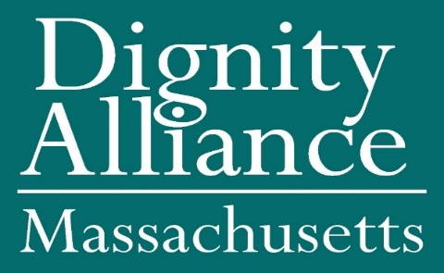

Resolution Urging the Massachusetts Congressional Delegation
to Correct the Social Security COVID Cut

Whereas, Older Adults and People with Disabilities in Massachusetts and all Americans age fifty or overs are already on edge about their financial and retirement security: The one-two punch of the pandemic and the economic crisis puts millions of people in our community in danger; and
Whereas, Social Security is the largest source of retirement income for most Americans and provides nearly all income for one in four seniors. And across the board — no matter party affiliation or age — the American public overwhelmingly supports Social Security; and

Whereas, Workers have paid into Social Security with every paycheck. It's a hard-earned benefit and a promise that must be kept; and

Whereas, Whereas, People turning age 60 in 2020 could see their Social Security benefits unfairly slashed simply because their lifetime benefits will be based on this year’s average wage index, which is dramatically lower because of the economic disruption of the pandemic; and

Whereas, The Social Security COVID cut is devastating news for around 4 million Americans born in 1960. Their lifetime benefits could be cut by up to $70,000 simply because the coronavirus has hurt the economy and reduced average wages this year; and
Whereas, Dignity Alliance for Massachusetts believes that such a calculation of benefits will diminish the dignity of older adults and people with disabilities through a reduction of their benefits as compared to their peers of other years; now, therefore, be it
Resolved, that Dignity Alliance Massachusetts, the largest state association of individuals and organizations advocating for dignity and quality of life for older adults and people with disabilities, hereby urge the members of the United States Congress representing Massachusetts, take a leading role in correcting this miscarriage of fairness, and be it further
Resolved, that a copy of these resolutions be transmitted to the Massachusetts Congressional Delegation.
Dignity Alliance Massachusetts is a broad-based coalition of organizations and individuals pursuing fundamental changes in the provision of long-term services, support, and care for older adults and persons with disabilities. Our guiding principle is the assurance of dignity for those receiving the services as well as for those providing them.
For more information about Dignity Alliance Massachusetts, please visit www.DignityAllianceMA.org. To contact us, email to info@DignityAllianceMA.org.
Resolution Urging the Massachusetts Congressional Delegation
to Correct the Social Security COVID Cut
Endorsements

This resolution has been endorsed by the following members of Dignity Alliance Massachusetts:
Boston Center for Independent Living
Center for Living & Work, Inc.
COP Amputee Association - COPAA
Disability Resource Center
Easter Seals
Greater Boston Chapter, United Spinal Associates
Greater Boston Legal Services
Independence Associates
Massachusetts Advocates for Nursing Home Reform, Alison Weingarten, Executive Director and Arlene Germain, Policy Director
MetroWest Center for Independent Living
Mystic Valley Elder Services
Doris Bardwell, RN
Frank E. Baskin, LICSW
Charles Carr, Former Commissioner, Massachusetts Rehabilitation Commission
Judi Fonsh, MSW, LICSW
Sandy Hovey
Wynn Gerhard, Esq.
Pamela Goodwin
Paul J. Lanzikos, Former Secretary of the Executive Office of Elder Affairs
Former Senator Richard T. Moore
Sandy Alissa Novack, MBA, MS
Scott M. Trenti, SeniorCare, Inc.

December 2020

