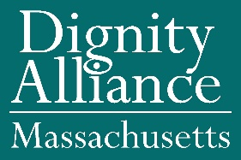

FY 2022 State Budget Amendment Endorsement

BUDGET ITEM – 9110 – 1640

Dignity Alliance Massachusetts advocates for the adoption of the following amendment affecting Line Item 9110-1640 (Executive Office of Elder Affairs):

Level funding at $1,000,000 with a requirement to add two new treatment sites.

Supporting information: This account was increased from $800,000 to $1 million in the FY ’21 budget, however, the Executive Office of Administration and Finance would not release the additional funding to operate two new sites claiming that they did not want to start new programs for which funding was not, necessarily, available in subsequent years.

Endorsed by twenty-six members of Dignity Alliance Massachusetts including:

Frank Baskin
Boston Center for Independent Living
Center for Public Representation
Disability Law Advocates
Lachan Forrow, MD
Wynn Gerhard
Greater Lynn Senior Services, Kathryn Burns, Executive Director
Sandy Hovey
James Lomastro, PhD
Paul J. Lanzikos
Massachusetts Advocates for Nursing Home Reform, Alison Weingartner, Executive Director, Arlene Germain, Policy Director
Mystic Valley Elder Services
Richard T. Moore

For questions or other communication, please contact Frank Baskin at BaskinFrank19@gmail.com.

Dignity Alliance Massachusetts is a state-wide, grass-roots coalition of aging and disability service and advocacy organizations and supporters dedicated to systemic transformation to ensure the dignity of older adults, people with disabilities, and caregivers. We are committed to advancing new ways of providing long-term services, support, living options, and care while respecting choice and self-determination. Dignity Alliance works through education, legislation, regulatory reform, and legal strategies to realize this vision throughout the Commonwealth.

