Judge grants receivership for historic Mission Hill nursing home on the brink of closure

By Jason Laughlin Globe Staff, Updated April 3, 2024, 8:00 p.m.

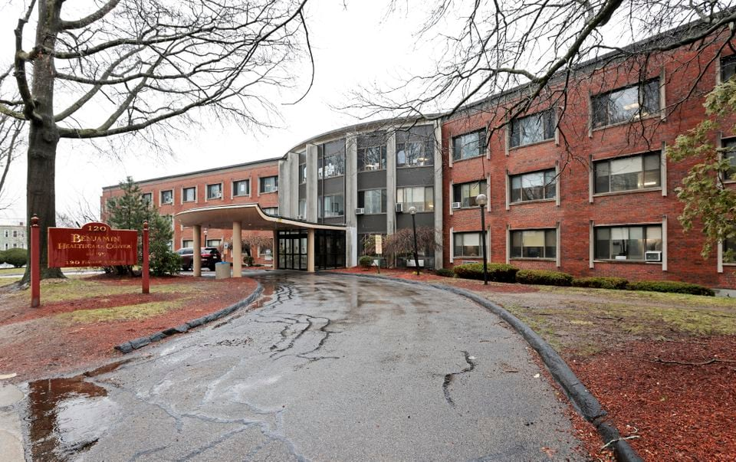
The Edgar P. Benjamin Healthcare Center serves primarily Black and Latino residents. PAT GREENHOUSE/GLOBE STAFF

A Mission Hill nursing and rehabilitation home that has prioritized care for Black patients was put in receivership Wednesday, a dramatic step that could save the home from a planned closure this summer.

Suffolk County Superior Court Judge Katie Rayburn agreed that conditions at the Edgar P. Benjamin Healthcare Center threatened the health and safety of its residents and appointed as receiver Joseph Feaster, a Boston attorney and chair of the city’s task force on reparations. He will take control of the home’s finances and management to stabilize a facility that has failed to meet payroll four times since November, according to court filings.

The Benjamin’s chief executive, Tony Francis, has said the facility, home to 71 people, is not financially viable and filed a proposal with the state to close the facility by July 1. Francis did not respond to a request for comment Wednesday.

The judge’s decision could be a lifeline for the facility. “Appointment of a receiver is a crucial first step toward stabilizing this venerable institution and ensuring the safety and well-being of the frail and elderly patients who live there,” said Oren Sellstrom, a Boston attorney with Lawyers for Civil Rights who filed the receivership petition.

Sellstrom had argued in the petition that mismanagement was to blame for the Benjamin’s plight, an allegation that Francis has denied. The receiver will help determine whether the Benjamin can be saved.

The decision to appoint a receiver came after a hearing Tuesday in which both the state attorney general’s office and the Department of Public Health voiced support for receivership. DPH had rejected a previous request for a receiver but changed course after learning the Benjamin was again not able to meet its payroll obligations, lawyers said.

“This creates an immediate danger in the event that employees who are not being paid will stop appearing for work,” said Stephen Davis, director of DPH’s division of health care facility licensure and certification, in an affidavit submitted Tuesday in Suffolk County Superior Court.

In a statement Wednesday, Attorney General Andrea Campbell said her office would continue to look into allegations of the facility’s financial mismanagement and noncompliance with its nonprofit filing obligations.

Adam Littman, the lawyer representing the Benjamin, argued during Tuesday’s hearing that the most recent payroll interruption happened after expected payments to the home were delayed, and that the state should allow the current management to move forward with the closure.
“The appointment of a receiver is not going to solve financial issues the facility has been experiencing,” he said.

The petition for receivership was filed last Thursday by Lawyers for Civil Rights on behalf of patients and their families. The petition requested Feaster be appointed receiver because of his standing in the community and his previous experience. He acted as receiver for the Roxbury Comprehensive Community Health Center for five years starting in 2013, according to the petition.

The nonprofit-run health care center is one of few New England nursing homes with a history of Black ownership and management and serves primarily Black and Latino residents. Its roots go back to 1927 when its namesake, a Boston lawyer, founded a nursing home, originally called Resthaven, to care for people, “without regard to race, creed or color.”

The Benjamin has received high marks from Medicare, but conditions have plummeted recently, according to the petition, which cited unsafe conditions and financial mismanagement by Francis, including questionable investments and loans and a salary for Francis of $628,000 in 2021, four times that of the next-highest-paid worker.

Francis said the home’s finances were decimated by the COVID-19 pandemic and cited inadequate MassHealth reimbursement rates and difficulty retaining workers amid competition from other employers as reasons the facility can’t survive.

The home’s staff, residents, and their families didn’t buy those justifications from Francis.
“It’s an injustice,” said Siena “Maria” Casas, 71, who moved to the Benjamin in 2018. “He’s asking us to leave when he’s the one who should leave.”

A native of Colombia, Casas has gradually lost her sight and is now blind.

Local politicians, including state Senator Liz Miranda and City Councilor Ben Weber, have been vocal about saving the historic home.

“This is a great outcome,” Weber said in a statement Wednesday. “Now we can get back to the work ensuring that the residents and the staff are treated with dignity and in accordance with the law.”
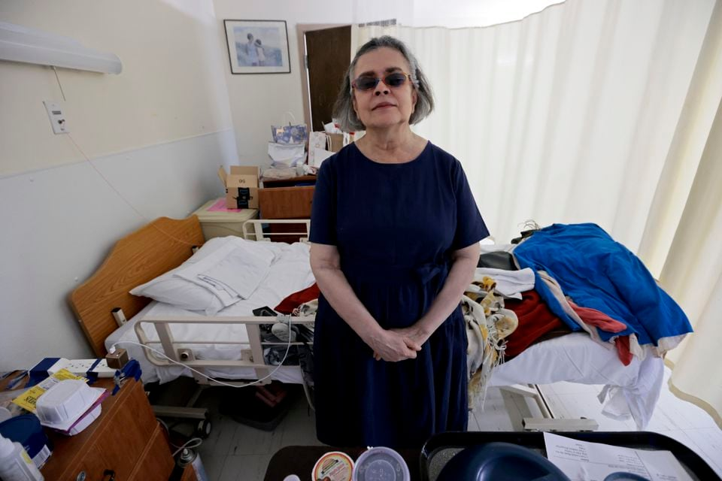
Siena "Maria" Casas has lived at the Benjamin since 2018.PAT GREENHOUSE/GLOBE STAFF

If the Benjamin closes, its loss would contribute to a steady decline in the number of nursing homes in the state, which reported a net loss of 56 between 2018 to 2023, according to DPH data. Five long-term nursing facilities in the state, including the Benjamin, have closed or filed plans to close so far this year, the agency reported.

Sellstrom, of Lawyers for Civil Rights, said he believes the Benjamin could survive with better management. His petition includes allegations of an investment in cryptocurrency that cost the home $100,000 and loans Francis made to the home at a 12 percent interest rate. Both decisions were approved by the Benjamin’s board, Francis said in emailed responses.

“I put personal funds at risk to cover immediate expenses because the facility has been financially failing,” he said, adding that the interest rate was better than those offered by banks and that he still hasn’t been repaid.

Francis’ 2021 pay was nearly three times what he made in 2017, according to financial filings. In a statement, Francis said the additional pay reflected the difficulty he faced running the home through the pandemic. His income declined to $333,594 last year.

The petition also stated the Benjamin had not paid vendors, was not repairing or replacing broken equipment, and had shortages of critical medical equipment. When the facility ran out of colostomy bags, one elderly resident had to be wrapped in a towel “to prevent feces from going everywhere,” the filing stated.

Francis disputed those allegations, saying a dietitian visits the facility and was on site this past weekend. There was one day when the home had an issue with supplies, he said, and it was able to compensate by borrowing bags from another facility, he said.

Casas, the woman from Colombia, still had her sight when she moved there, which makes it easier to still get around now. Relocating would mean getting to know a new environment entirely by touch.

“I have a little stress because you take me somewhere, and [I’m] just stuck, because I don’t know where to walk,” she said.

Jason Laughlin can be reached at jason.laughlin@globe.com. Follow him @jasmlaughlin.

